**Creating Local YUM Repository in RHEL 7.x**

This tells about how to create local YUM repository in red hat enterprise Linux let’s move on..

**Step1:**

Open terminal and check for Repo by entering following command.

**Yum repolist**



Here you can see right now there is no repo I mean 0 repolist , so we need to create local repo lets begin.

**Step2:**

copy OS image file to one directory else if you are connected to **dvd** drivewhich has installation **dvd** then follow the further steps..



I copied ISO file to **rhel** directory as above

**Step3:**

Create new directory.

C:\Users\guru\Desktop\doc\Capture14.PNG

You can check by entering **ls** command as follows.



**Step4:**

Mount the directory which your ISO file exists to the newly created directory that is **redhat7** as follows..

C:\Users\guru\Desktop\doc\Capture16.PNG

Change directory to redhat7 and check everything is ok and here you will find some files and packages as follows.

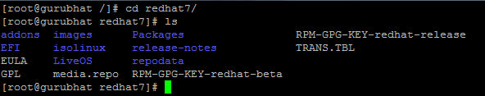

Again change the directory to Packages .

C:\Users\guru\Desktop\doc\Capture18.PNG

Enter **ls** commands to view the packages.

C:\Users\guru\Desktop\doc\Capture20.PNG

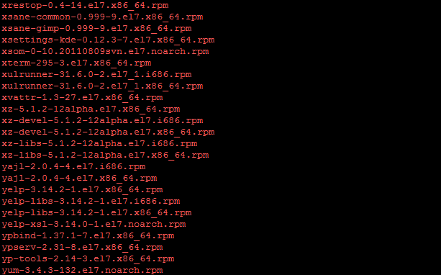

**Step5:**

Install some dependent packages for creating local repository as below.

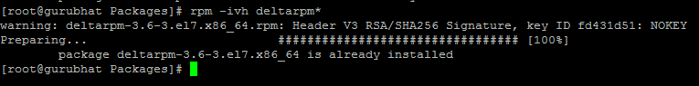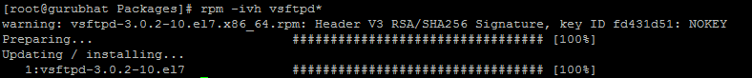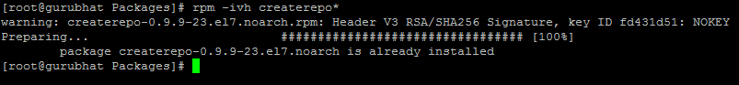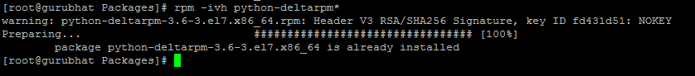

after installing change the directory to /etc/yum.repos.d.

C:\Users\guru\Desktop\doc\Capture25.PNG

Enter **ls** command here you will find right now there is no local repository.

C:\Users\guru\Desktop\doc\Capture26.PNG

**Step6:**

Create local file with extension .repo, here I am using vi editor.

C:\Users\guru\Desktop\doc\Capture27.PNG

Edit the file as below.

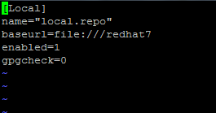

Here name is your repo name whatever name you can give but extension should be .repo,

**Baseurl** is nothing but it is the directory which you mounted to iso earlier,

Now lets check repolist

**Yum repolist all**

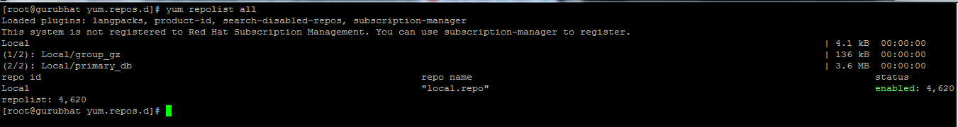

You can see our local repository is create success fully and it is enabled now you can install packages using YUM

>>>>>>>>>>>>>>>>>>>>>>>>>>>>>**Thank You**<<<<<<<<<<<<<<<<<<<<<<<<